**Group Members:** Miguel Carmen

Michael Dugan

Mitchell Nuyens

Kayla Osburn

**Course:** ENGR 114, Fall 2019

**Date:** 12/9/2019

**Revision:** 2

**“Automatic” Blind: Hardware Hookup Guide**

**Purpose:**

The purpose of this build is to assemble and program a device to receive user input to activate a light sensitive motor which will use logic to roll up a window blind.

**Materials:**

|  |  |  |  |  |
| --- | --- | --- | --- | --- |
| **Part Name** | **Purpose** | **Item Name** | **URL** | **Price** |
| Mercury Motor SM-42BYGH | Shade motor | Motor | <https://www.sparkfun.com/products/9238> | $15.95 |
| Sparkfun Redboard + Breadboard | Logic board | Arduino | <https://www.sparkfun.com/products/13975?_ga=2.227501533.1384250415.1575879362-253292.1571262260> | $19.95 |
| LDR Sensor | Photoresistor | LDR |  | $1 |
| LED bulb | LDR indicator | LED |  | < $1 |
| 12V wall tranformer | Driver Power | 12V |  | $5 |
| Jumper wires | Connect pins | wires |  |  |
| Resistors (10k and 220 ohm) | Resistor | Resistor |  | < $1 |
| Sparkfun EasyDriver | Motor Driver | Driver | <https://www.sparkfun.com/products/12779> | $14.95 |
| Gears | Shade drivetrain | gears | Custom | n/a |
| Wooden frame, rolling dowel | Shade structure | Device | Custom | $20 |
| Fabric | Shade | Shade | Custom | n/a |

**Hookup Guide:**

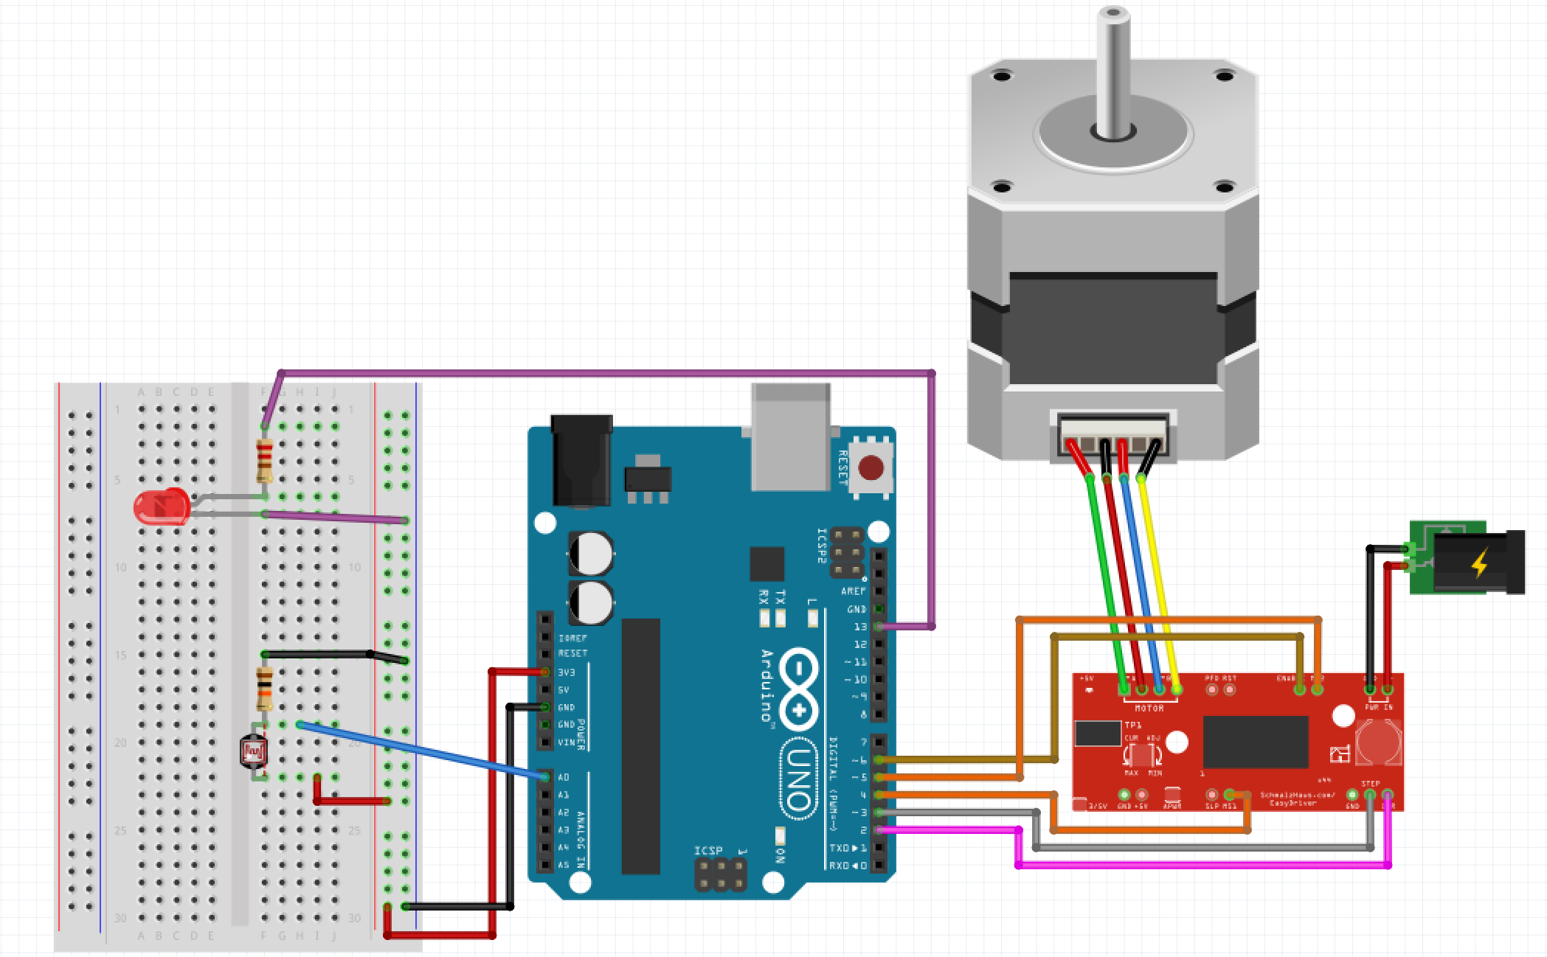

**Images:**